Carbody Structure and Exterior

Introduction

Use

Purpose

Parts List

All figures are assigned to an individual page unless views are required to show a complete listing of equipment.
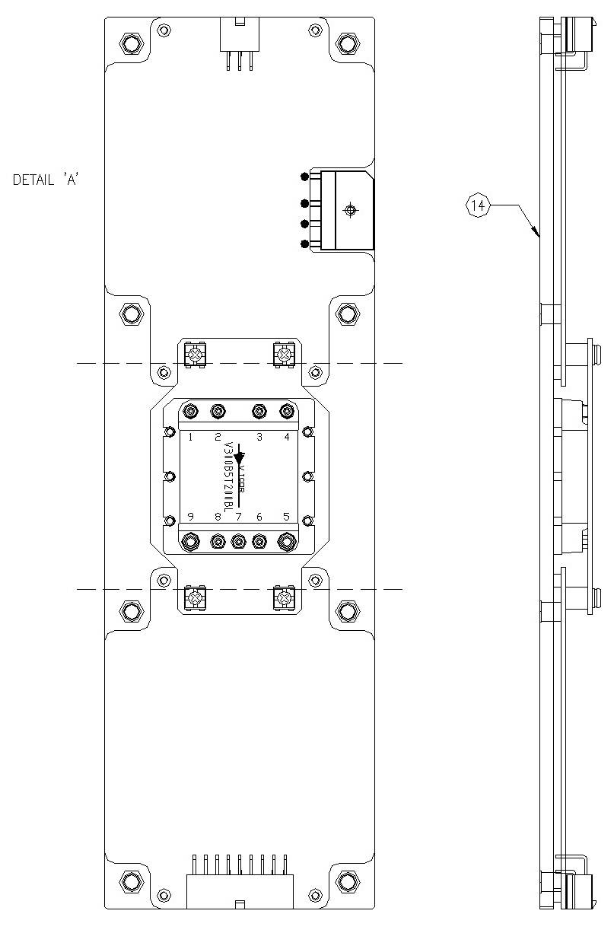

Figure 2.1. FDI_SDI Power Board1

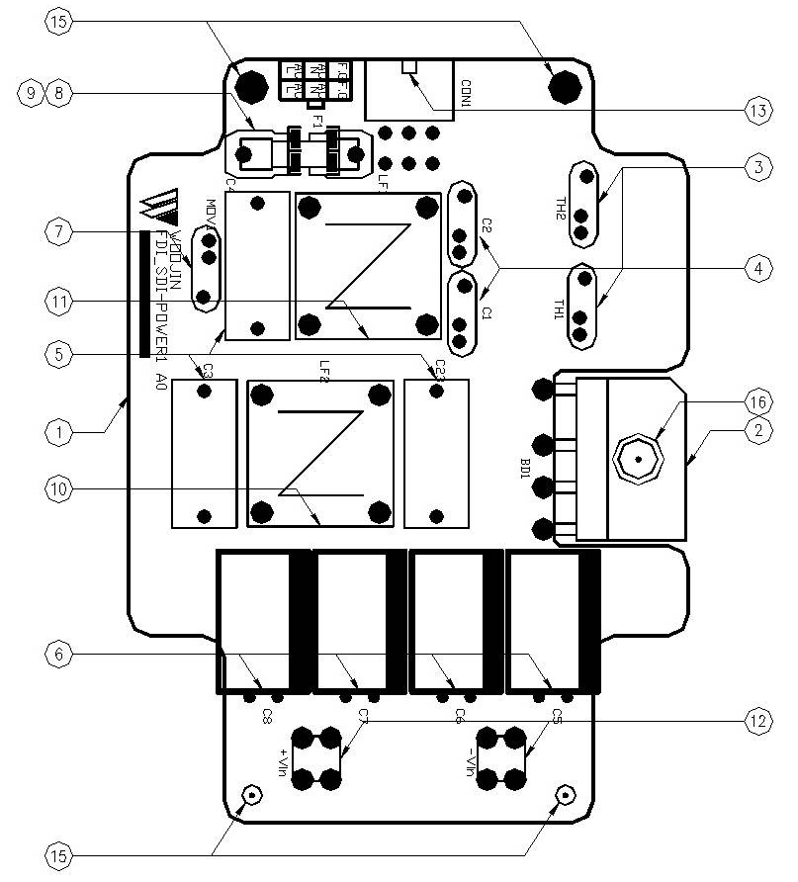

Figure 2.2.1. FDI_SDI Power Board1 (Detail A)

Table 1 - Figure 2.1. FDI_SDI Power board1
FIG No. | PART NUMBERS |  |  | ITEM DESCRIPTION | VENDOR CODE | QTY
 | HRC | VENDOR | DTP
1 |  | FDI_SDI-POWER1 A0 |  | . BOARD | HANSAEM | 1
2 |  | D15XB60 |  | . BRIDGE DIODE | SINDENGEN  RECTRON  DIODES | 1
3 |  | DSC150K5SB  DEC5D15  SYP5D15 |  | . THERMISTOR | DSC  DEC  KORYO | 2
4 |  | SDE2E472  HCFZ2G472MAAP10 |  | . CERAMIC CAPACITOR | SAMWHA  NETRONTECH | 2
5 |  | PCX2-335-MJ474  MPX474K31D5 |  | . FILM CAPACITOR | PILKOR  CARLI | 3
6 |  | KMG(NHA)400VB47M7.5TP  RD2G476M1631MPA |  | . ELECTROLYTIC CAPACITOR | SAMYOUNG  SAMWHA | 4
7 |  | INR14D471  SVC471D-14A |  | . VARISTOR | AMOTECH  SAMWHA | 1
8 |  | 0215010.MXP  55T 250V 10A |  | . FUSE | LITTLE FUSE  ORISEL | 1
9 |  | FH51  GF205 |  | . FUSE HOLDER | YEONHO  GEO YOUNG | 1
10 |  | 2mH/6A, Φ27, RA |  | . LINE FILTER | TAESUNG  DAEKWANG | 1
11 |  | 2mH/3A, Φ12, RA |  | . LINE FILTER | TAESUNG  DAEKWANG | 1
12 |  | BR111, M3.5X8 |  | . SUPPORT | BEE RYONG | 2
13 |  | LAD1140-06P |  | . CONNECTOR | HANLIM | 1
14 |  | AI, D330 X L100 X H13 |  | . HEAT SINK | EGPOWER | 1
15 |  | ROUND, M3XL6mm |  | . BOLT |  | 4
16 |  | ROUND, M3XL10mm |  | . BOLT |  | 1

